|  |  |
| --- | --- |
| **Bank of AmericA Merrill Lynch Research Document**  **Machine Learning** | **Abstract**  Research and Technical Architecture document regarding machine learning techniques for model development.  **Michael Smith x00107586**  4th Year Project |

Contents

Introduction 2

Scope of the project 2

Previous paper on the topic 2

Machine Learning 3

Supervised Learning 3

Unsupervised Learning 3

Reinforcement Learning 4

Microsoft Azure Machine Learning 5

Test Experiment 5

Neural Networks 6

How Neural Networks Work 7

Customizing an experiment using R 10

Visual Studio with NuGet 11

FOREX 11

Other data 11

Conclusion 13

References 13

# Introduction

The goal of this project is to look at how machine learning technology can be used for financial modelling. Using an alternative method to model development I want to see how a few machine learning techniques can be applied to the model development space.

What I want to find out is whether using these machine learning techniques I can improve effectiveness and performance in this space.

In the following paper I will discuss some of the research I have done and the technology I will be using to create the project.

# Scope of the project

What I am going to do for this project is to take information regarding foreign exchange data throughout previous years. The data I will be looking at will be the opening and closing rates and also the high and low rates for each day throughout the time window. I will then take this information and using Microsoft Azure Machine Learning software I will train and test the data using several different machine learning algorithms and to see if I can predict future foreign exchange rates based on the exchange rate information over the past decade or so. I will then take the model that I think gives the best results and convert it to a web service. From here I will create a webpage that will allow a user to enter a specific date in the future and the website will call from the web service for the foreign exchange data forecasted for that date.

# Previous paper on the topic

There has already been a previous paper (found here <https://www.researchgate.net/profile/Mohamed_Fakhr/publication/236896558_FOREX_Daily_Trend_Prediction_using_Machine_Learning_Techniques/links/00b4951a0db303a56b000000.pdf>) written about predicting FOREX daily trend prediction using Machine Learning techniques. In the paper the author looked at technical analysis and signal processing for several time windows and used this information for predicting the high rate on a daily basis. The machine learning algorithms that the author used in the paper were Support Vector Machine (SVM) which is a classification method where the data is plotted and each piece of data being a pair of coordinates on a dimensional space. A line is found that will then split the data into classified groups. The other algorithm was Bagging Tree which is used to improve stability and accuracy in machine learning classification. The author then chose the best features for the experiment from the data and then trained the data. The features where changed numerous times to see different results which are then compare against each other to see which technique gave the best results. Then using a Percentage Normalized Profit function (PNP) the author compared the predicted trends to the profit that would be made under ideal predictions.

The results of the paper showed that using the systems the author had created there could be a practical use for machine learning within the trading market.

# Machine Learning

So, what is Machine Learning?

Machine Learning is a form of computing that works off pattern recognition and using previous information a computer can learn to do tasks without having previously been programmed to. Machine learning uses complex algorithms that can recognise patterns in data and using this previous knowledge can then be applied so that it can predict patterns in newer data.

It is generally thought that Machine Learning can be broken down into 3 different categories:

### Supervised Learning

Supervised Learning is the process of making predictions using data. In other words, I already know the data that I am inputting and the output. I am trying to create a mapping function so that when I enter new data I can predict what the output will be.

This is done by training the model with the data I have input and continuing to train the model until I achieve an accurate result.

Some examples of Supervised Learning problems are

* Classification
* Regression

Classification problems are when I want to categorise the output. For example, whether an email is spam or not spam.

Regression problems are when I want to output an actual value. For example, this can be a sum of money or like what I want to display, a foreign exchange rate.

### Unsupervised Learning

Unsupervised Learning is different from Supervised Learning in the sense that I don’t know what the output data is. Because of this, Unsupervised learning does not necessarily give us a correct answer because there is not one correct answer. Instead Unsupervised Learning techniques will look at the input data and try to find differences and similarities amongst it and give us a cluster of results based on summaries of the input data.

Some examples of Unsupervised Learning problems are

* Clustering
* Association

Clustering is where you want to find out the different groups in the data. For example, if I had a group of people I could group them by height or ethnicity.

Association is where I want to find relationships between the data I have input. For example, if a person buys a certain item they also buy another specific item, i.e. a person purchases a computer and also purchases a mouse.

### Reinforcement Learning

Reinforcement Learning is different from the other two learning techniques in the way that it only learns something at the end of the decisions being made. It is similar to how a human would learn which is by doing something and then looking back at how they could improve what they have done. (Sutton, 1992) describes Reinforcement Learning as

*“The learner is not told which action to take, as in most forms of machine learning, but instead must discover which actions yield the highest reward by trying them.”*

A good example of this would be creating a program to play chess and at the end of the game if the program lost, it could look back at the moves it made and assess whether it could have made a better move somewhere in the game and learn from this for the next time.

There are many different machine learning algorithms that can be applied to any data and I have included a picture below of the most common ones.

*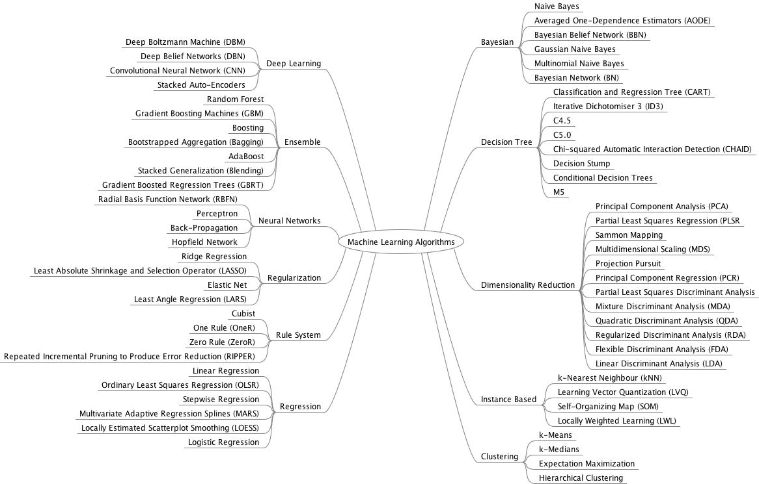(Sridharan, 2015)*

The category this project falls under is supervised learning as I will be training a model with previous data and using this data to make predictions. The project will fall either into Regression, if I want to find an actual value, or Classification if I just want to find out whether the value I am trying to predict will either increase or decrease. I may try to produce a model for each of these categories by creating a model using a neural network regression algorithm and a two-class neural network algorithm. I will be taking the foreign exchange data that I have downloaded and training and testing several models and using the model with the most accurate prediction for the project.

# Microsoft Azure Machine Learning

The service that I will be using to train and predict the outcomes of the data is Microsoft Azure Machine Learning. This tool is a cloud based service that provides a visual workspace that will enable me to create and train predictive models on the data I input. Azure Machine Learning also allows me to deploy the model as a web service. Azure Machine Learning reduces complexity by using a drag-and-drop interface which will allow me to build a model without writing any code. This is very helpful because if I was writing code it would take a long time to continuously iterate a model so this allows for quick experimentation with different models.

# Test Experiment

I have previously completed a tutorial on Azure Machine Learning where the goal was to predict the future prices of several different automobiles. The original dataset was a sample dataset that was included within the program. The dataset contained information regarding such as make, model, specs, mileage and price.

The next step was to clean the dataset as it contained some rows and columns with missing values. I had to remove these missing values so that the model can correctly analyse the data. I also removed a column that was missing a large amount of data as this would not affect the outcome.

After this I wanted to select the columns or features that I wanted to include in the model. Some of the columns within the dataset would not influence the prediction I wanted to make so I only chose specific features that would give the model good information.

Once the data was cleaned it was now time to choose a machine learning algorithm. So, for this predictive model I wanted to find a value and as I mentioned before this falls into the Supervised Learning category, more specifically a Regression model which is used to find a number.

Using a linear regression mode, I split the dataset to 75% training and 25% testing and selected price as the column I wanted to train. I ran the experiment on the 75% train and when finished I then used the other 25% to score the model. This then gave me the predicted information that I wished to find out. To test the quality of the results I then evaluated the model and the results I received showed that the predictive model was a good one.

Using steps similar to the ones above I will take the foreign exchange rates data and apply a similar experiment but using different algorithms and changing the features involved. I will iterate over the model editing numerous details to try and improve the model.

In regards to the machine learning algorithms that might be applicable to the project I will test several different modules. I have already created an experiment in Azure Machine Learning studio using a Linear Regression algorithm using only a few features but will attempt this again when I have more accurate features that will affect the output

I will mainly be concentrating on creating an experiment and using a Neural Network algorithm on the model.

# Neural Networks

Neural Network models are used for statistical learning. The layout of a neural network is something like the central nervous system in the human brain. A neural network consists of three different sections – an input layer, a hidden node layer and an output layer.

* The input layer will be made up of input nodes in which I will place the features of the foreign exchange dataset that I think will influence the future rates.
* The hidden node layer is responsible for taking the inputs and applying functions to the values and returning the output. There can be several different layers in the hidden node section with each applying a different function to the values. This is called the hidden node layer as it is not visible as an output from the network.
* In the output layer, I have a target value that I want the hidden node layer to return. The closer I am to the target value the better the algorithm.

So when I want to create a neural network to predict a numerical value that is a prediction of what a feature will be in the future. The process I used to find the value is called forward propagation. To do this I will enter the features that I think will have an effect upon the rate of a currency pair. This will consist of features such as previous high and low rates and open and close rates. I will also be adding some economical features which would have an effect on the rate also. These features are the input nodes of the neural network.

From here I will add the properties that I want the neural network algorithm to apply when training the dataset. The default properties set the number of hidden nodes in the hidden node layer to 100. The hidden node layer can contain more than a single layer and in fact can contain many. When a neural network consists of many layers it is referred to as “deep learning”, this produces more powerful and faster machine learning but for the moment I will be dealing with a single layer of hidden nodes. All of the input nodes will be interconnected to each one of these hidden nodes and the neural network algorithm will apply a weight value to each connection between the input nodes and the hidden nodes. The weight value is a randomly generated value between 0 and 1 for each connection between the input nodes and the hidden nodes. This weight will then be multiplied by the value of the input node and the resulting value will be stored in the hidden node.

From here the hidden node will apply one of several different activation functions to the value produced from multiplying the input and the weight assigned to it. The activation function will take the input value and transform it into an output value. The resulting value will be the final value for that hidden node. To get the output value I will then repeat the process of multiplying the value in the hidden nodes by a randomly assigned weight value on the connection between the hidden nodes and the output. I will then take the results of these calculations and add them together to produce the output value. Again, I apply the activation function to this value and this will result in the final output.

I will then compare this value to the target value. If the difference between these values is too much I will need to make some changes along the process to get a value that is closer to the target.

To do this I will use back propagation. Using back propagation, I will begin at the output layer and working backwards I will change the weight values for each connection between the nodes based on the margin of error between the target and the result we got.

When the new values for the weights have been adjusted, I will then forward propagate through the network again and I should get a result closer to the target. By completing several iterations of forward and backward propagation I will eventually reach the target value.

# How Neural Networks Work

Below are some images of how forward and backwards propagation work done on a neural network by (Miller, 2015)

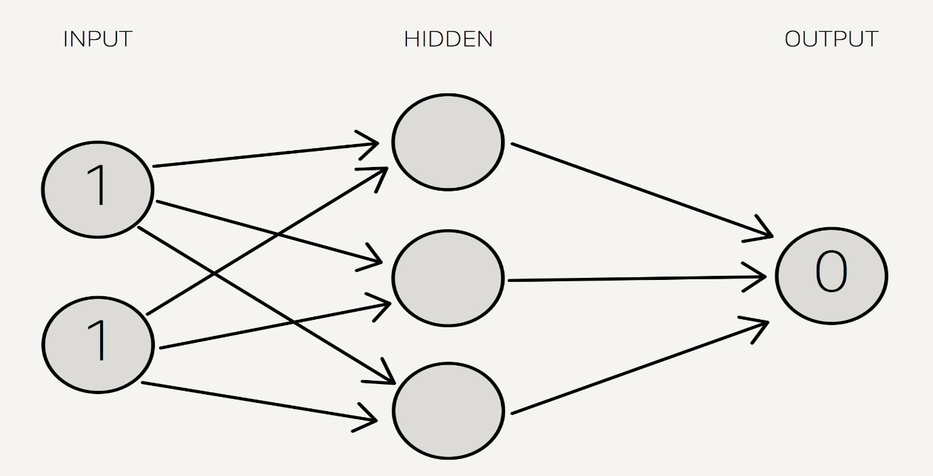

*[a] We have the inputs and target*

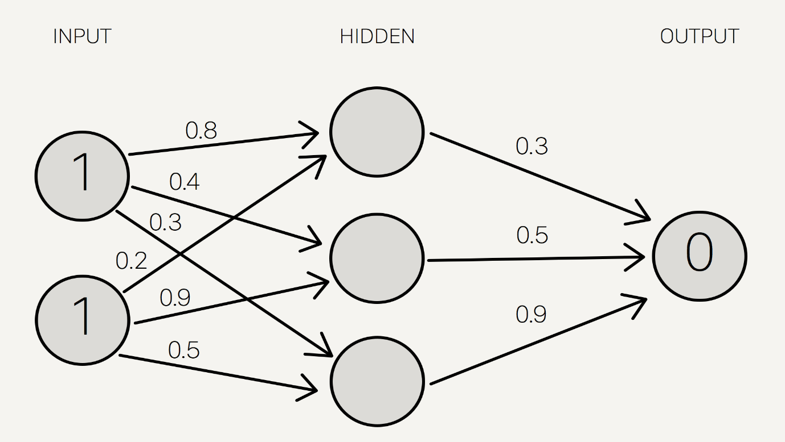

*[b] Network after applying weights*

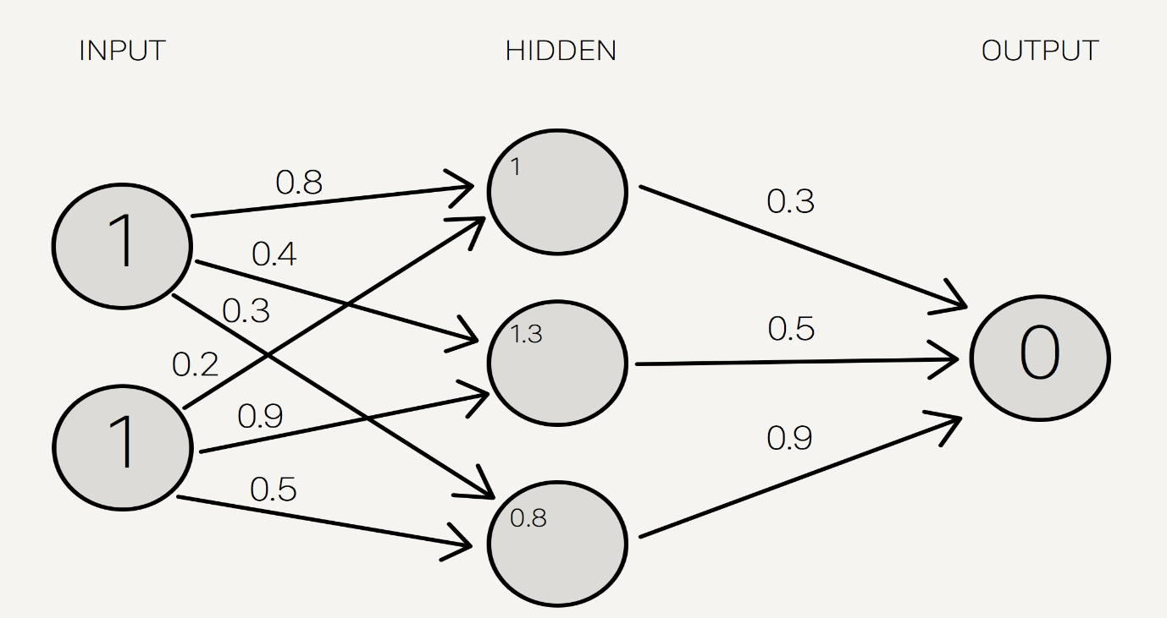

*[c] Network after summing the weights and the inputs*

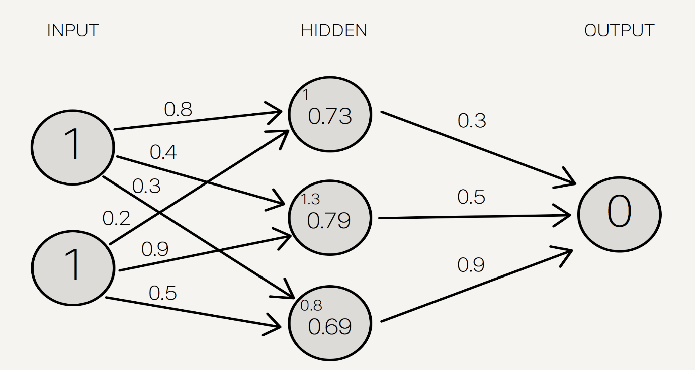

*[d] After applying activation function*

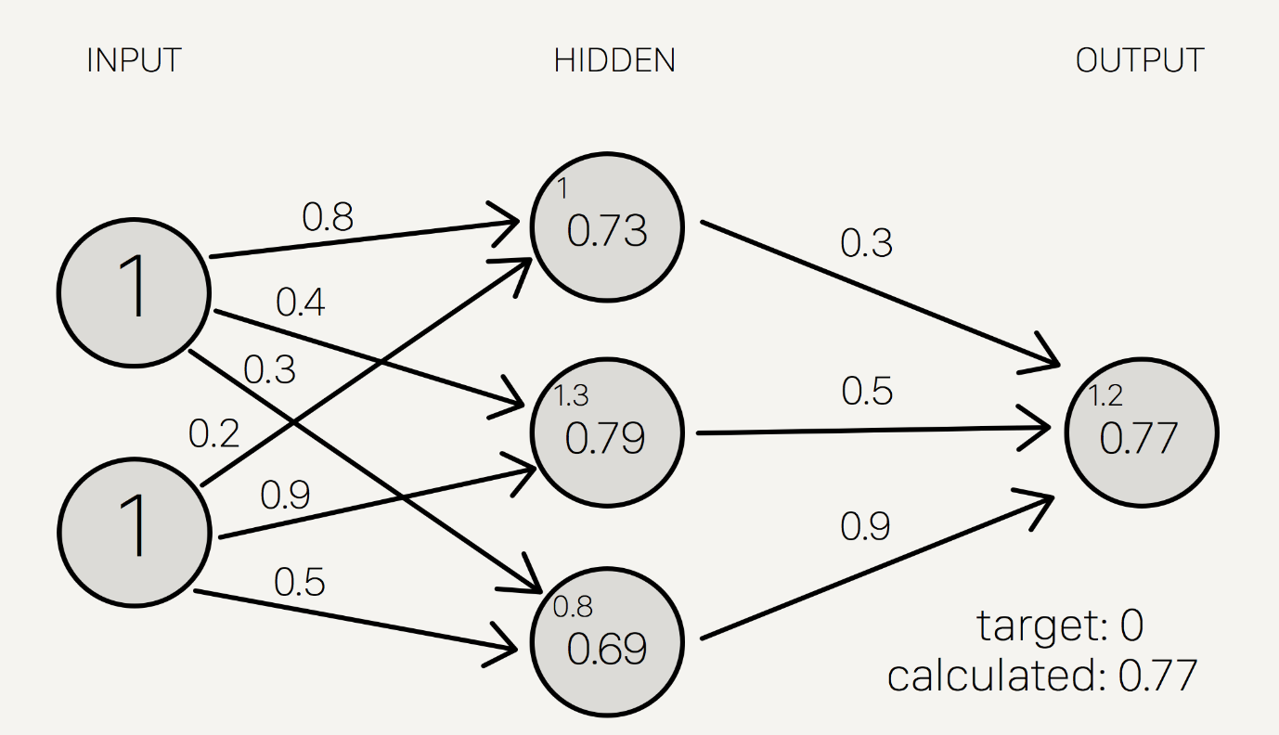

*[f] Result*

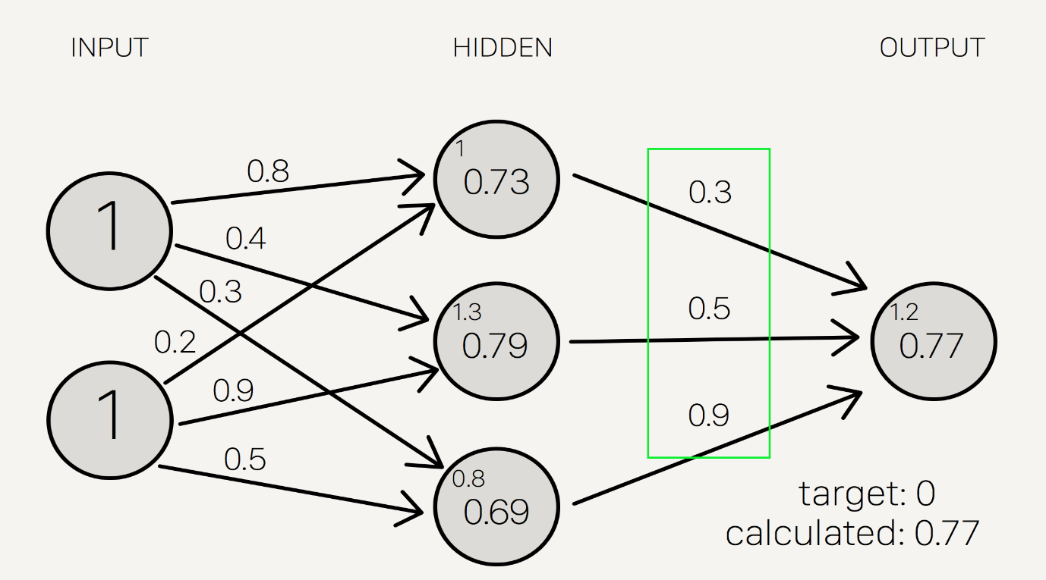

*[g] Back propagation changing the weights*

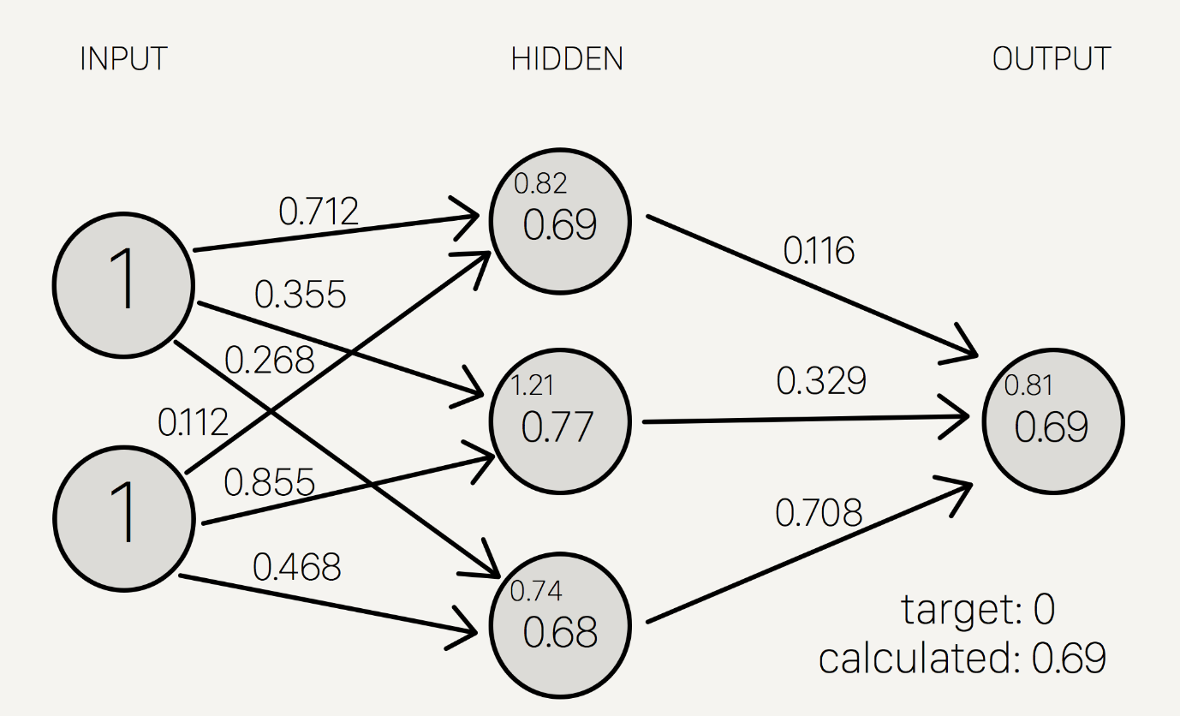

*[h] Result after back and forward propagation again. Closer to target.*

Neural networks produce better results with more data and bigger models and more computation.

In regards to the machine learning algorithms that might be applicable to the project I will test several modules. I think that a Neural Network Regression algorithm would be a good choice as it is used for accuracy with a long training time. Along with this the Two-class neural network and the Multiclass neural network are two more algorithms I would like to test. These algorithms will allow me to tune the module with different parameters, number of iterations, etc. Although complex, neural networks are very powerful.

I will also try a linear regression algorithm to test the prediction and compare the results against the neural network modules.

# Customizing an experiment using R

In the Azure Machine Learning environment, I can use R language in the experiments. R is a programming language that is used for statistical computing and data analysis. I can use extensive open source R libraries in my existing analytics code. To use R in an experiment I need to use the execute R script module. I can paste my R code into the script window, then using the dataset I connect it to an input port on the execute R script module.

Once the dataset has been connected to the module I can now use the information in that dataset within the R script. I can map the dataset to the port and can now edit the data using this script by adding additional libraries if needed and creating new features within the dataset. I can then clean up the data so I can use it in the R code. By using R in the project this gives me the ability to add extra features that I may need when building, training and testing a model.

# Visual Studio with NuGet

I will be using Visual Studio to create a simple console application that will allow a user to enter a date and receive a prediction for the foreign exchange rate information for that specific day. Using NuGet, which will add references and classes for machine learning into the environment and allow me to make a REST call. Visual Studio contains a built in NuGet package manager that can add these features with a line of code in the package manager console.

# FOREX

The data that I will be using is foreign exchange rates. The figures for this data were a result of the trading done in the FOREX market.

FOREX or the Foreign Exchange market is a global market for the trading of currencies. The market allows people to purchase and sell currencies. Every day an average of more than 3 trillion dollars in transactions takes place in the market. The transactions on this market in time cause a change to the exchange rate between currencies making them either stronger or weaker. FOREX traders attempt to predict whether an exchange rate will get stronger or weaker. The idea is to purchase an exchange pair when they think the exchange rate will increase and sell when they think an exchange rate will decrease. Because FOREX is a global market these types of trades are happening 24 hours a day 5 days a week.

The data I will be using for the project is the opening, closing, high and low figures from this market over a defined time window. I will take a few currency pairings and using the data and machine learning algorithms try to predict whether a currencies exchange rate value will increase or decrease. I have downloaded the data regarding these figures from [www.forextester.com](http://www.forextester.com) and the data ranges from January 2001 – 31 October 2016 giving me 16 years’ worth of data that I can train and test.

# Other data

The rate of an exchange rate is not just decided by the buying and selling of a currency pair but rather is dependent on several factors. A country’s economy plays a massive part in whether that country’s currency rate is going to increase or decline.

Some other factors that affect the foreign exchange rate:

* **Unemployment Rates**

A country’s unemployment rate will play a part in deciding the strength of that country’s currency. If a country’s unemployment levels are rising, then that shows that that country’s economy is weak and therefore the currency’s worth will drop. On the other hand, if the country’s levels of employment start to increase this is an indicator that the country’s economy is doing well and will thereby increase the strength of that country’s currency.

* **Interest Rates and Inflation**

Interest rates also have a strong impact on the strength of a countries currency. If a country has high interest rates, then that tends to increase the value of that country’s currency. When the interest rates are high this also tends to bring in more foreign investors which in turn leads to an increase in demand of that country’s currency. But when interest rates rise this also tends to lead to an increase in inflation which leads to a countries currency weakening. If a country can find a way to increase their interest rates without increasing inflation, then that countries currency and exchange rates are likely to increase as well.

* **Gross Domestic Product**

(*Gross domestic product (GDP)*, 2016)

***“Gross Domestic Product (GDP)****is the broadest quantitative measure of a nation's total economic activity. More specifically, GDP represents the monetary value of all goods and services produced within a nation's geographic borders over a specified period of time.”*

The GDP levels are usually compared against the previous year and of the level of GDP is up then this usually indicates that the economy has grown and will therefore lead to an increase in the country’s currency strength. The opposite is true if the GDP is down.

* **Geopolitical Events**

Another factor that can affect a countries foreign exchange rate is political events within that country. We have seen recently with Brexit that the exchange rate between the British pound and other currencies changed drastically after Britain voted to leave the European Union.

These are just some of the many other factors that can affect the foreign exchange rate values and I will be considering these factors when I am attempting to predict the future exchange rate values.

# Conclusion

After researching the topics above I feel that I have gathered enough information to begin to create the project. I have now had experience using Microsoft Azure Machine Learning to create an experiment and use an algorithm to create a prediction. I have read a previous paper regarding the topic and have seen that using machine learning techniques, predicting FOREX trends is possible. I also have downloaded the data that I will be using in the experiment and am currently working on creating a basic experiment using this data.

# **References**

*Ref 1*, Sutton, R. (1992). *Reinforcement Learning*. Boston, MA: Springer US, pp.1 - 3.

Jixta. 2016. *Machine Learning Algorithms Mindmap | Jixta.* [ONLINE] Available at: <https://jixta.wordpress.com/2015/07/17/machine-learning-algorithms-mindmap/>. [Accessed 10 November 2016].

*Gross domestic product (GDP)* (2016) Available at: http://www.investinganswers.com/financial-dictionary/economics/gross-domestic-product-gdp-1223 (Accessed: 6 December 2016).

Miller, S. (2015) *Mind: How to build a neural network (part One)*. Available at: http://stevenmiller888.github.io/mind-how-to-build-a-neural-network/ (Accessed: 10 December 2016).